Autoencoders
An autoencoder is a type of artificial neural network used for unsupervised learning. Its main goal is to learn an efficient representation of input data, typically for purposes such as dimensionality reduction, feature learning, noise removal, or data compression. Instead of predicting labels, an autoencoder tries to reconstruct its own input at the output layer. By forcing the network to pass the data through a smaller internal representation, it learns the most important patterns and structures in the data.
Autoencoders are widely used in machine learning tasks like anomaly detection, image denoising, recommender systems, and pretraining deep networks. They work on the intuition that if a network can accurately reproduce the input after compressing it, then the compressed form must capture the essential features of the data.

How Autoencoders Work
An autoencoder consists of two main parts:
- Encoder
The encoder compresses the input into a lower-dimensional representation called the latent vector or bottleneck representation.
It maps input x to hidden representation hhh:
h=f(Wx+b)
where W and b are weights and biases, and f is an activation function.
- Decoder
The decoder reconstructs the original input from the latent representation:
x=g(W′h+b′)
The output {x} is compared with the original input x, and the network is trained to minimize reconstruction error using loss functions like Mean Squared Error (MSE) or Binary Cross-Entropy.

Raw Architecture of an Autoencoder
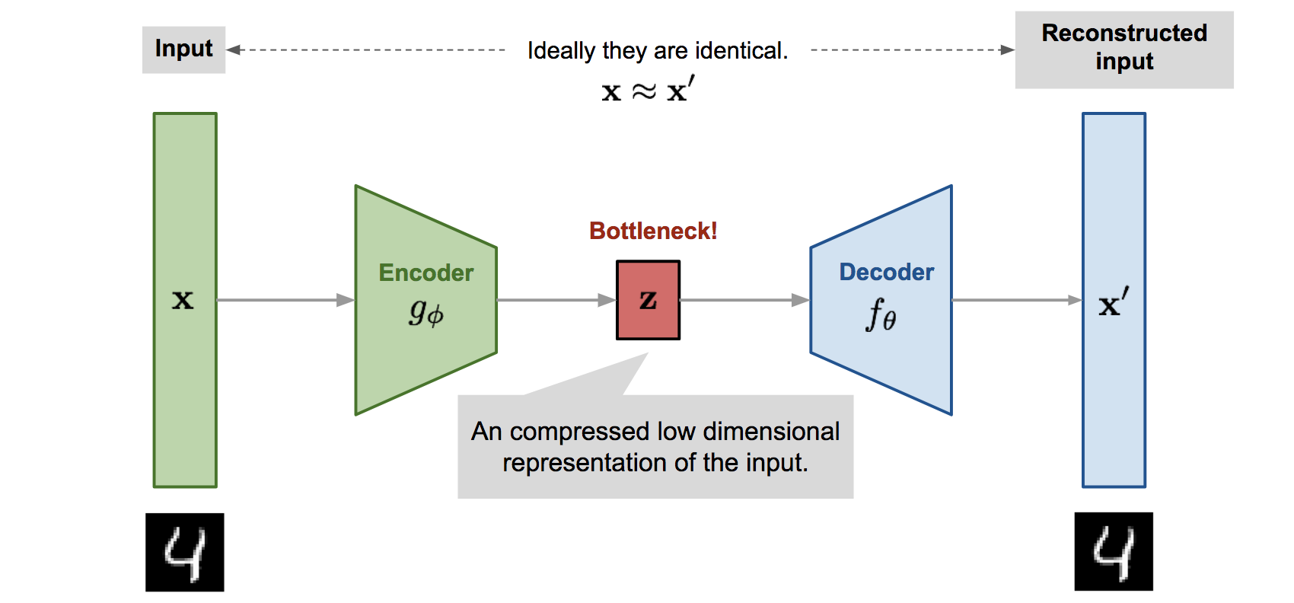
The basic (raw) architecture is symmetrical and consists of three core layers:
1. Input Layer
- Receives the original data vector
- Example: an image flattened into pixels
2. Hidden Bottleneck Layer (Latent Space)
- Smallest layer in the network
- Stores compressed representation
- Forces the network to learn meaningful features
3. Output Layer
- Same size as the input layer
- Produces a reconstructed version of the input

Variants of Autoencoders
- Sparse Autoencoders – impose sparsity constraints
- Denoising Autoencoders – reconstruct clean data from noisy input
- Variational Autoencoders (VAEs) – learn probabilistic latent spaces
- Convolutional Autoencoders – used for image data

